## Mastering Micro services with Java -Part 2-Whole Practice Assignment

**1. Problem:**

1. Develop a project using java with the implementation of the Micro services for performing the web application operations and display the results. Develop a project for configuring the Authentication API and perform the operations for validating the user inputs.

**Solution:**

**Please find the application code and execution flow screens below.**

**Application.java:**

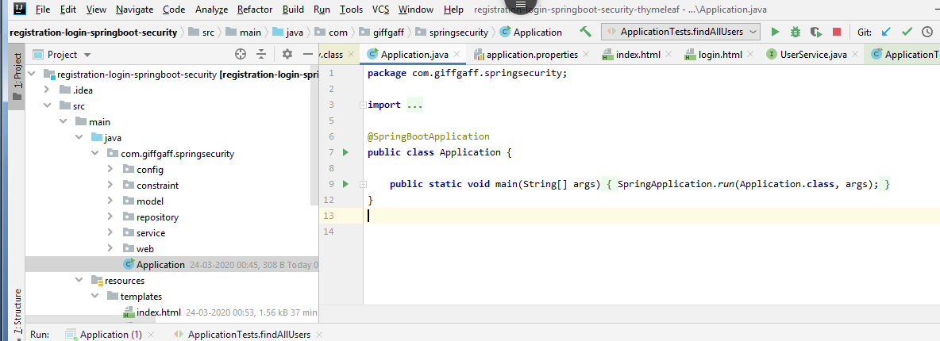

**Security Configuration.java:**

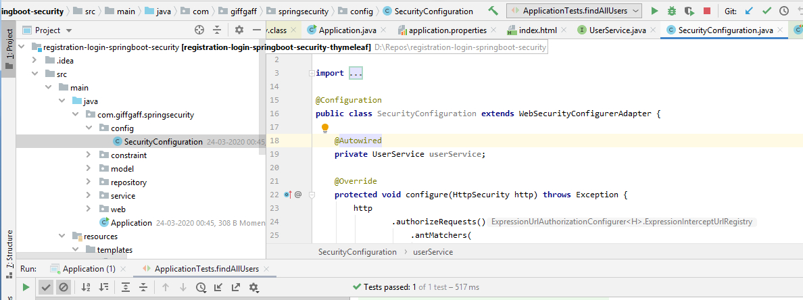

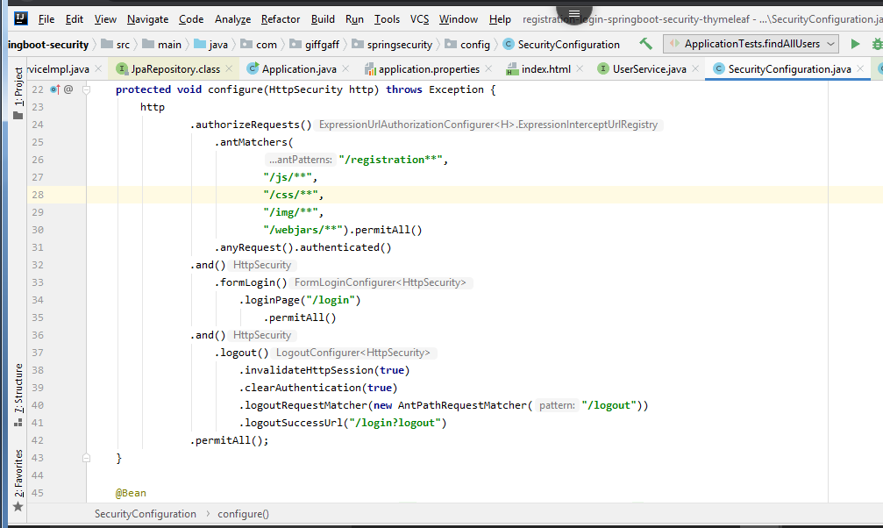

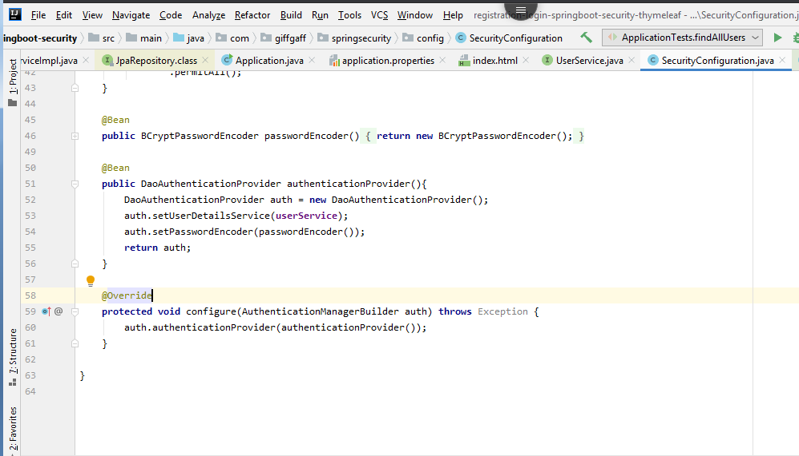

**FieldMatch.java:**

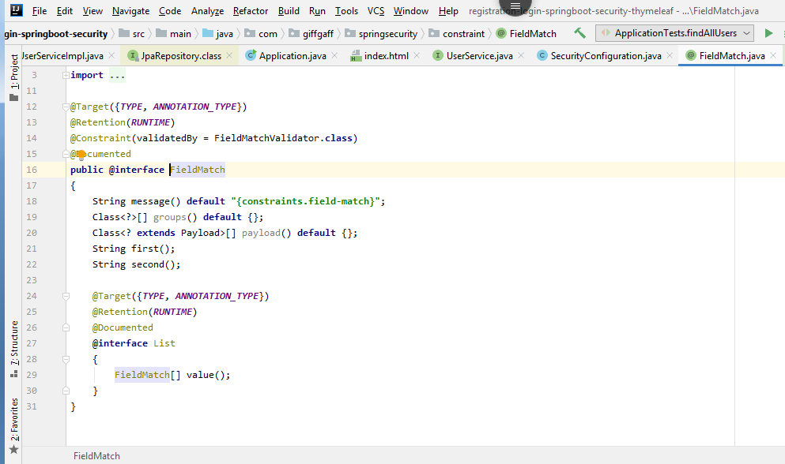

**FieldMatchValidator.java:**

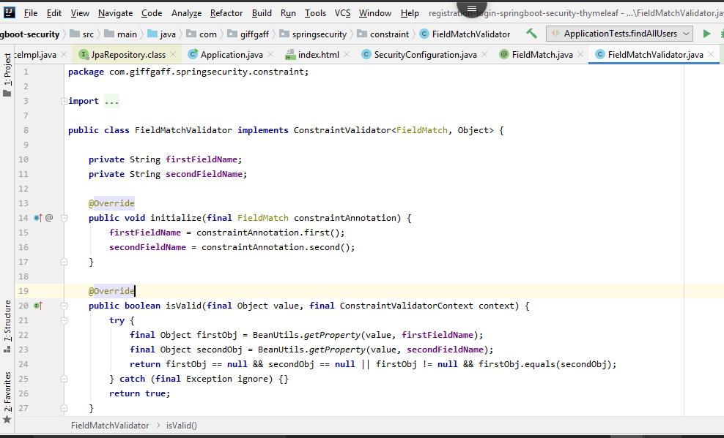

**Role.java:**

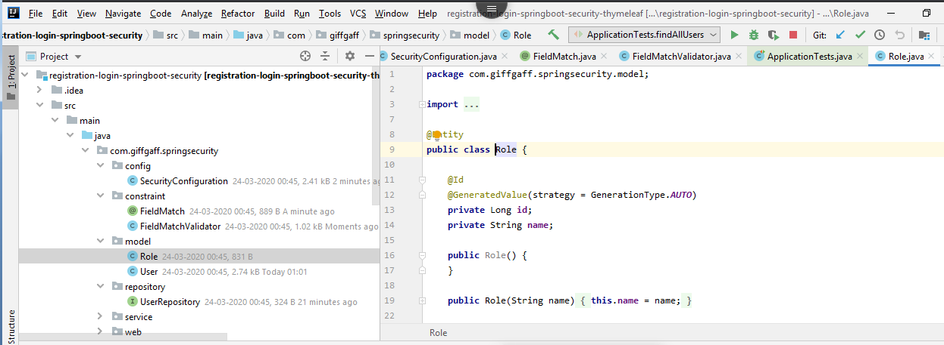

**User.java:**

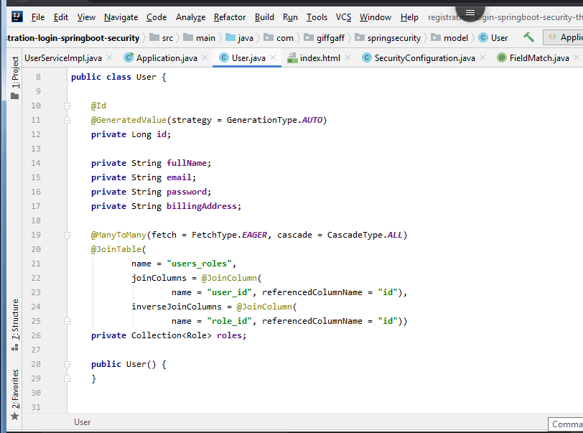

**UserRepository.java:**

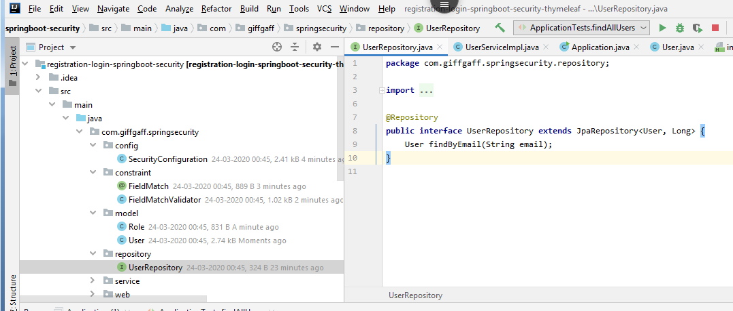

**UserService.java:**

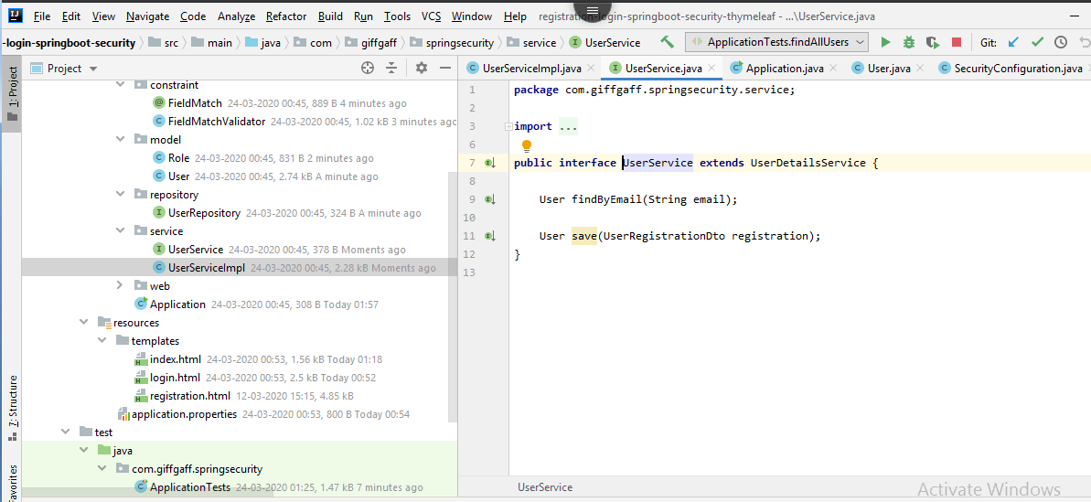

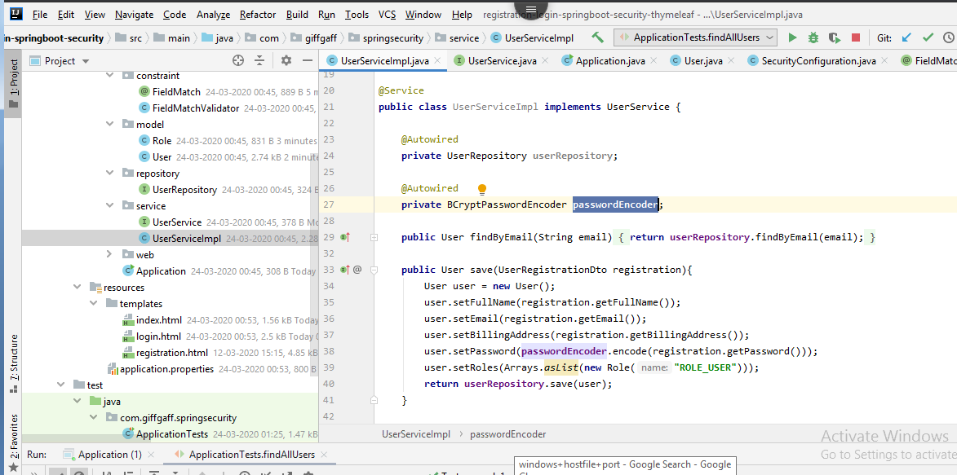

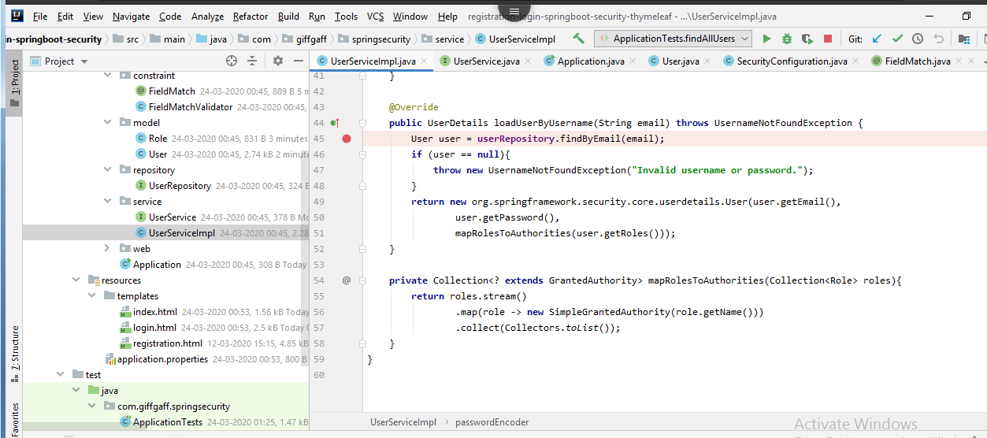

**Index page:**

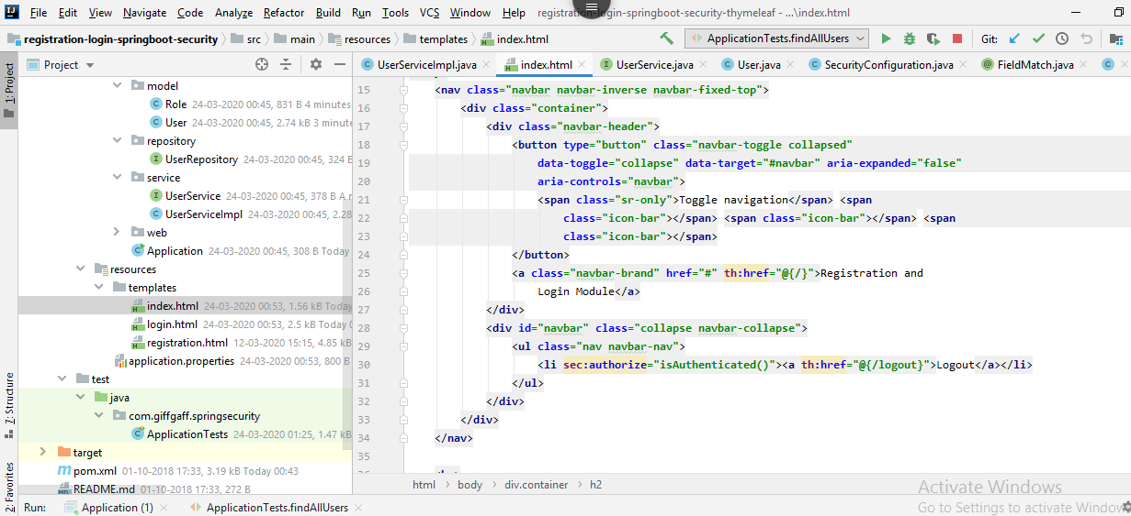

**Login Page:**

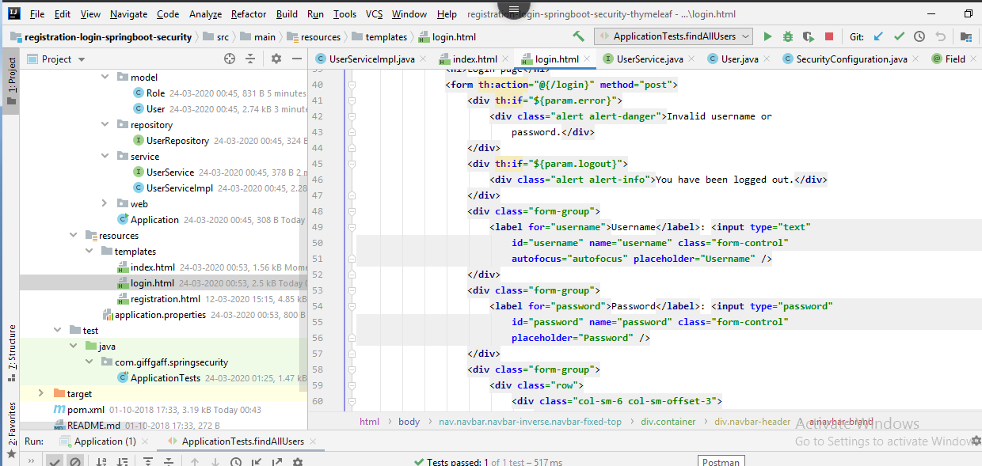

**Registration Page:**

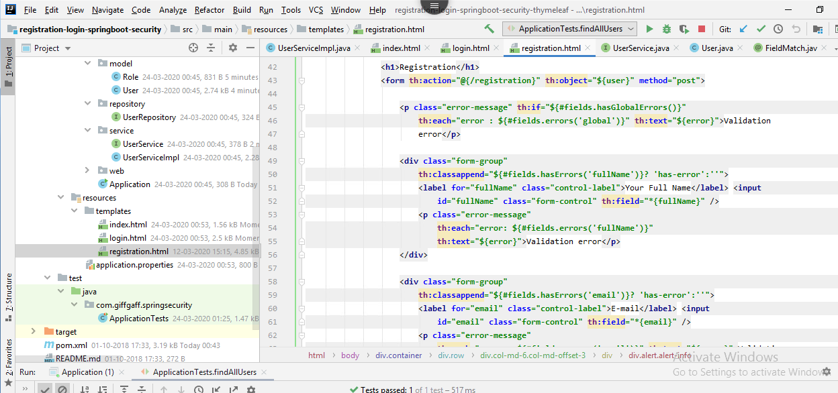

**OauthConfiguration:**

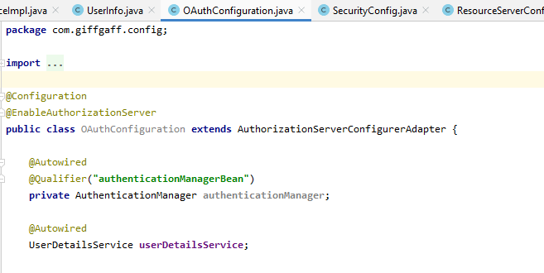

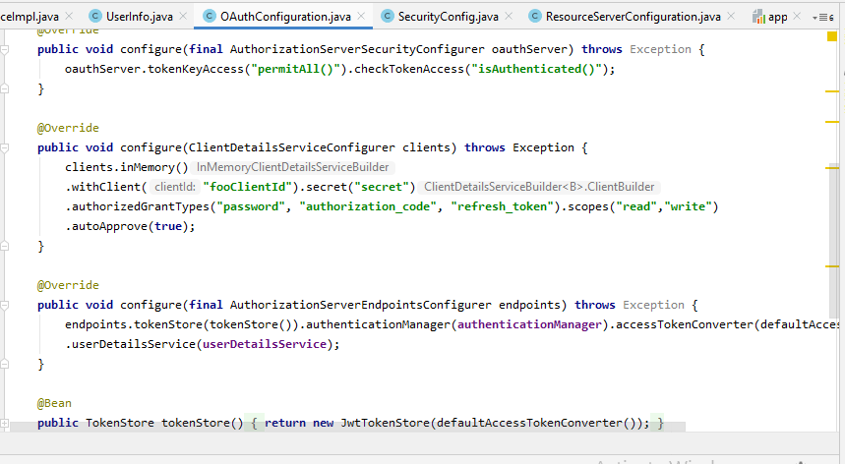

**Run Application:**

**Login Page:**

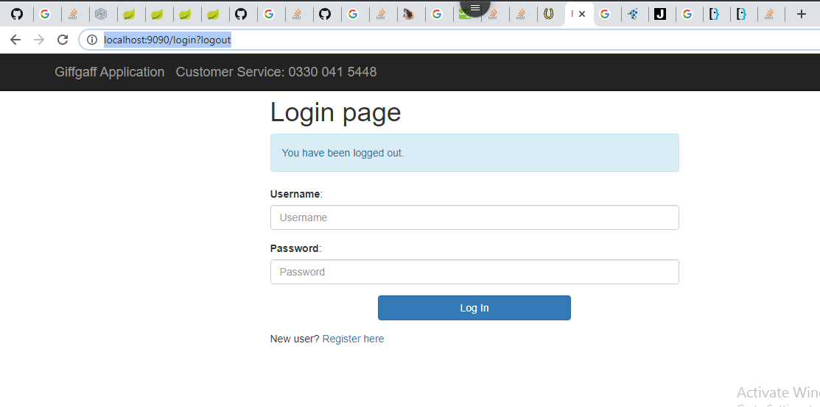

**Registration Page:**

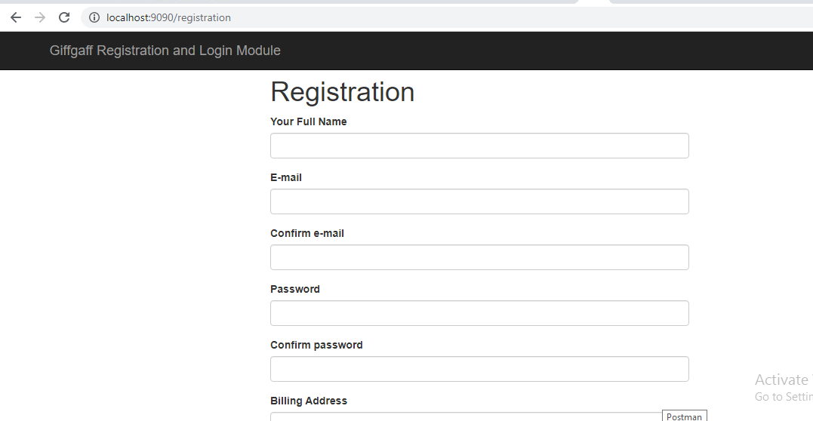

**Registration Form Submition:**

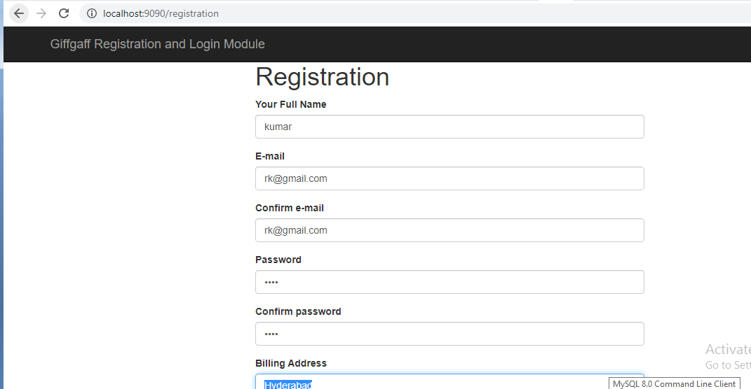



**Successful registration message:**

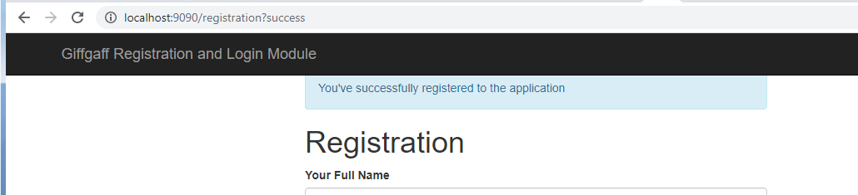

**Login with Valid User:**

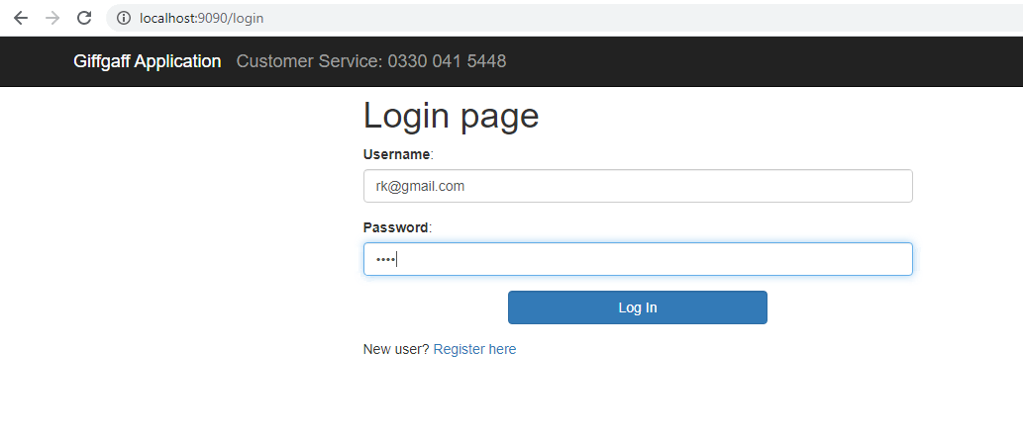

**Welcome page:**

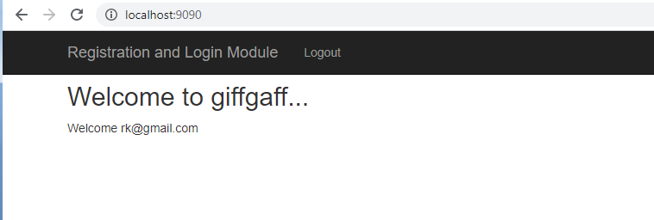

**Invalid username/password Error:**

